

**Modern Web Application(MWA)**

**Mini Project Report**

**On**

**Car Rental Or Car Washing Website**

**By: Siddharth Pandya(A023)**

**Suraj Pankaj(A024)**

**Abhijith Pillai(A029)**

**Introduction:**

**Abstract:**

Customers will be able to reserve their vehicles from anywhere in the world due to the Car Rental System. Consumers provide information to this application by filling in their personal information. When a consumer creates an account on the website, he or she can reserve a car. The proposed system is an online system that is fully integrated. It effectively and efficiently automates manual procedures. Customers are aided by this automated method, which allows them to fill in the specifics according to their needs. It contains information on the sort of car they want to hire as well as the location. The goal of this system is to create a website where customers can book their automobiles and request services from anywhere in the world. There are three phases to this car rental system mentioned in the introduction.

**PROJECT AIMS AND OBJECTIVES:**

The project aims and primary objectives are:

To develop a website offering car renting and car washing services.

Car rentals are useful for people who either don’t have personal vehicles or have their car damaged or under repairs, etc. And Car Washing is useful for people who uses their car daily and there is no facility to wash and clean their vehicle.

The users of the car rental project are divided into three groups:

Admin - Users responsible for managing car rental services.

Registered users - Users who have already registered on the website.

Guest users - Users that are visiting the website without any registration.

In addition to PHP, the project leverages Bootstrap, and jQuery.

**BACKGROUND OF PROJECT:**

**Problems of existing system**

1) Bad Design of site.

2) Hard to navigate.

3) Waiting time to get any book in college library.

4) Book not being Available

5) Book not being there.

**Project/ System Analysis**

**Software tools used:**

The whole Project is divided in two parts the front end and the back end.

FRONT END: The front end is designed using of HTML, PHP, CSS, Java script, Jquery, Angular, Bootstrap

**1. HTML-** HTML or Hyper Text Mark-up Language is the main mark-up language for creating web pages and other information that can be displayed in a web browser.HTML is written in the form of HTML elements consisting of tags enclosed in angle brackets (like <html>), within the web page content.

**2. CSS- Cascading Style Sheets (CSS)** is a style sheet language used for describing the look and formatting of a document written in a mark-up language. While most often used to style web pages and interfaces written in HTML and XHTML, the language can be applied to any kind of XML document, including plain XML, SVG and XUL. It can also be used to allow the web page to display differently depending on the screen size or device on which it is being viewed.

**3. JAVA SCRIPT-** JavaScript (JS) is a dynamic computer programming language. It is most commonly used as part of web browsers, whose implementations allow client- side scripts to interact with the user, control the browser, communicate asynchronously, and alter the document content that is displayed. It is also being used in server-side programming, game development and the creation of desktop and mobile applications.

**4. BootStrap-**

Bootstrap is the most popular HTML, CSS and JavaScript framework for developing a responsive and mobile friendly website. It is absolutely free to download and use.It is a front-end framework used for easier and faster web development.It includes HTML and CSS based design templates for typography, forms, buttons, tables, navigation, modals, image carousels and many others.

It can also use JavaScript plug-ins.It facilitates you to create responsive designs.

**BACK END**- The back end is designed using MySQL which is used to design the databases

1. MYSQL- MySQL ("My S-Q-L", officially, but also called "My Sequel") is (as of July 2013) the world's second most widely used open-source relational database management system (RDBMS). It is named after co-founder Michael Widenius daughter, My. The SQL phrase stands for Structured Query Language. The MySQL development project has made its source code available under the terms of the GNU General Public License, as well as under a variety of proprietary agreements. MySQL was owned and sponsored by a single for- profit firm, the Swedish company MySQL AB, now owned by Oracle Corporation .MySQL is a popular choice of database for use in web applications, and is a central component of the widely used LAMP open source web application software stack (and other 'AMP' stacks).

**2) PHP-** PHP is a server-side scripting language designed for web development but also used as a general-purpose programming language. PHP is now installed on more than 244 million websites and 2.1 million web servers.

Originally created by Rasmus Lerdorf in 1995, the reference implementation of PHP is now produced by The PHP Group. While PHP originally stood for Personal Home Page, it now stands for PHP:

**Screen Shots**

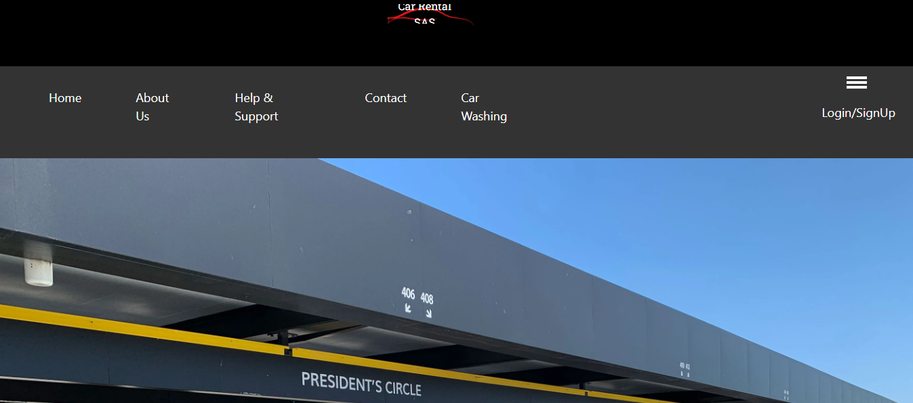

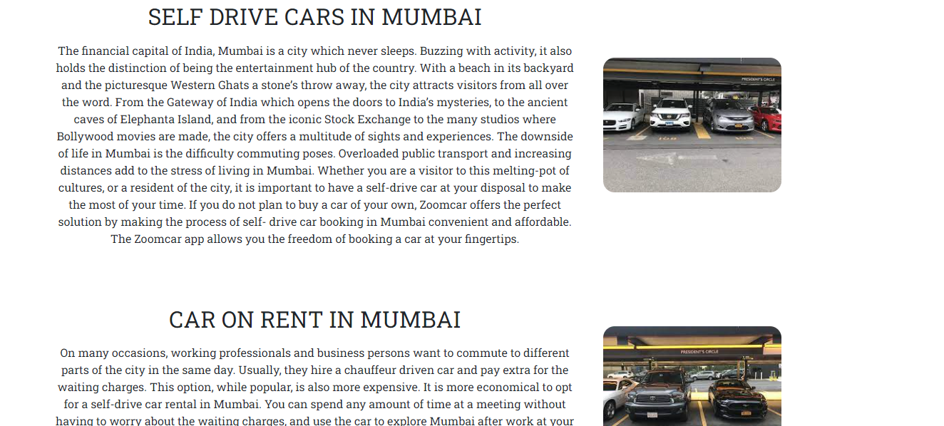

Code:

<body>

    <header>

      <div class="head-img">

        <a href="index.html"><img id="top-img" src="Images/SAScarrental.png" alt="" /></a>

        <div class="name" id="name">

          <div class="heading">SAS </div>

          <div class="work">Car Rental</div>

        </div>

      </div>

    </header>

    <nav class="navbar h-nav-resp" >

      <ul class="nav-list v-class-resp">

        <li><a href="#Home">Home</a></li>

        <li><a href="#About">About Us</a></li>

        <li><a href="#">Help & Support</a></li>

        <li><a href="#Contact Us">Contact</a></li>

        <li><a href="#">Car Washing</a></li>

  </ul>

  <div class="rightNav v-class-resp">

    <a href="login and signup.html">Login/SignUp</a>

  </div>

  <div class="burger">

    <div class="line"></div>

    <div class="line"></div>

    <div class="line"></div>

  </div>

</nav>

<main>

Css

h1 {

  font-size: 36px;

  font-weight: 600;

}

.header {

  min-height: 100vh;

  width: 100%;

  background-image: url(./Images/car\ rent\ photo.webp);

  background-position: center;

  background-size: cover;

  position: relative;

}

.header-car-washing {

  min-height: 100vh;

  width: 100%;

  background-image: url(./Images/pexels-jan3354648.jpg);

  background-position: center;

  background-size: cover;

  position: relative;

}

.header-login-signup {

  min-height: 100vh;

  width: 100%;

  background-image: url(./Images/photo4.jpeg);

  background-position: center;

  background-size: cover;

  position: relative;

}

**Registration and SignUp**

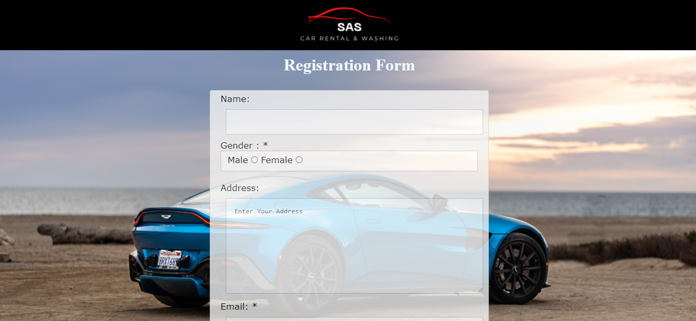

Code

<header>

        <div class="banner">

            <a href="index.html"><img src="./Images/SAS 3.gif" alt="" /></a>

        </div>

    </header>

    <form method="post" action="http://localhost/MWA/registrationform.php">

        <h1 class="main_heading"> Registration Form</h1>

        <div class="register">

            <p>Name: <input type="text" name="name" id="name" /></p>

            <p>Gender : * </p>

            <fieldset>

                <p>

                    Male

                    <input type="radio" name="gender" id="male" value="Male" required />

                    Female

                    <input type="radio" name="gender" id="Female" value="Female" required />

                </p>

            </fieldset>

            <br>

            <p>

                Address:

                <textarea name="address" id="address" cols="10" rows="10" placeholder="Enter Your Address"></textarea>

            </p>

            <p>

                Email: *<input type="email" name="email" id="email" required placeholder="abc123@gmail.com" />

            </p>

            <p>Password *<input type="password" name="pass" id="pass" required placeholder="***"></p>

            <input type="submit" value="Register" onclick="validate()">

        </div>

Css

body {

  background-image: url(./Images/pexels-tyler-clemmensen-6239334.jpg);

  background-position: right;

  background-size: cover;

  position: relative;

  min-height: 100vh;

  width: 100%;

}

.register {

  font-family: Verdana, Geneva, Tahoma, sans-serif;

  margin: 15px 30px;

  font-size: 17px;

  padding: 8px;

  width: 40%;

  background-color: #f2f2f2;

  padding: 5px 20px 15px 20px;

  border: 1px solid lightgray;

  border-radius: 4px;

  margin: auto;

  margin-top: 30px;

  box-shadow: initial;

  opacity: 0.8;

}

input[type="text"],

input[type="email"],

input[type="password"],

textarea {

  width: 100%;

  padding: 16px;

  border: 1px solid #ccc;

  margin: 10px;

}

**Jquery:**

$(document).ready( function() {

  $("div").hover( function() {

      $(".name").slideToggle("slow");

    });

});

$(document).ready(function() {

  $("div").hover( function() {

    $('.cardone').animate({

      'boxShadowX': '30px',

      'boxShadowY':'30px',

      'boxShadowBlur': '20px'

  });

})

});

burger = document.querySelector('.burger')

navbar = document.querySelector('.navbar')

navList = document.querySelector('.nav-list')

rightNav = document.querySelector('.rightNav')

burger.addEventListener('click',()=>{

  navList.classList.toggle('v-class-resp');

  navbar.classList.toggle('h-nav-resp');

  rightNav.classList.toggle('v-class-resp');

})

**Registration php**

$firstname = $_POST['name'];

$gender = $_POST['gender'];

$addres = $_POST['address'];

$email = $_POST['email'];

$pass = $_POST['pass'];

/*echo "Welcome ".$fullname;*/

$sql = "INSERT INTO users (firstname,gender,addres,email,pass)  VALUES ('$firstname', '$gender', '$addres', '$email', '$pass')";

$select = mysqli_query($conn, "SELECT * FROM users WHERE email = '" . $_POST['email'] . "'");

if (mysqli_num_rows($select) > 0) {

    // exit('This username already exists. Go Back to Registration');

    echo "<script>alert(\"This username already exists\");window.location.href = \"http://localhost/MWA/Mini%20Project/Registration&Signup.html\";</script>";

    // header("location: http://localhost/MWA/Mini%20Project/Registration&Signup.html");

    exit;

}

Car Washing

**Code:**

 <header>

    <div class="banner">

      <a href="index.html"><img src="./Images/SAS 3.gif" alt="" /></a>

    </div>

  </header>

  <nav>

    <a class="menu-btn" href="#Home">Home</a>

    <a class="menu-btn" href="#s">About Us</a>

    <a class="menu-btn" href="#">Help & Support</a>

    <a class="menu-btn" href="#Contact Us">Contact</a>

    <a class="menu-btn" href="./index.html">Car Rental</a>

    <a href="login.php" class="menu-btn flex-align-right">Login/SignUp</a>

  </nav>

  <main>

    <section class="header-car-washing" id="Home">

      <div class="btn1">

        <button class="washing-btn" type="submit"> Book Now</button>

        <!-- <h1>SAS Car Rental & Car Washing</h1> -->

        <!-- <div class="container-washing"> -->

}

nav a:hover {

  color: rgb(70, 41, 151);

}

.copyright {

  float: right;

}

.flex-align-right {

  margin-left: auto;

}

.menu-btn:hover {

  background-color: #ddd;

}

section {

  text-align: center;

  padding-top: 40px;

  height: 120vh;

}

.text-box {

  width: 90%;

  color: white;

  position: absolute;

  top: 50%;

  left: 50%;

  transform: translate(-50%, -50%);

  text-align: center;

}

.text-box h1 {

  font-size: 62px;

}

.text-box p {

  margin: 10px 0 40px;

  font-size: 14px;

  color: white;

}

.banner a {

  height: 100px;

  background-repeat: no-repeat;

  background-position: top center;

  background-size: 40%;

  background-attachment: fixed;

  display: flex;

  justify-content: center;

  /* align-items: center; */

  background-color: black;

}

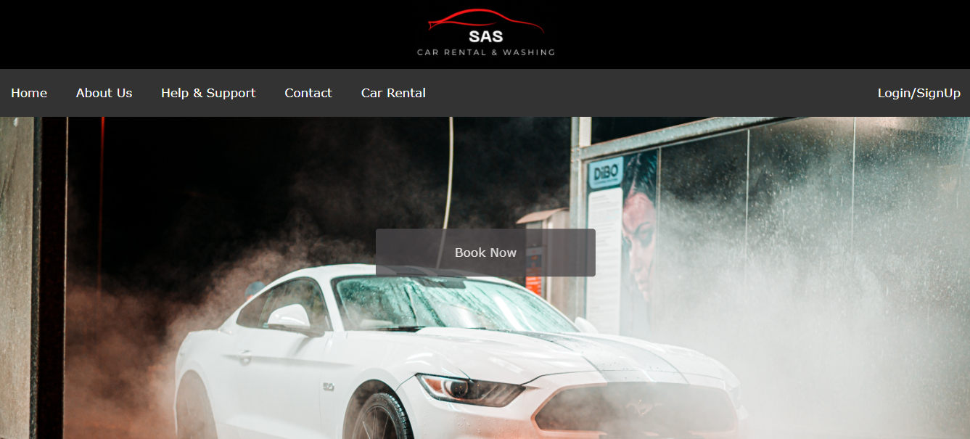

Login

<?php

//This script will handle login

// check if the user is already logged in

if (isset($_SESSION['email'])) {

    header("location: welcome.php");

    exit;

}

require_once "database.php";

$email = $password = "";

$err = "";

// if request method is post

if ($_SERVER['REQUEST_METHOD'] == "POST") {

    if (empty(trim($_POST['email'])) || empty(trim($_POST['password']))) {

        $err = "Please enter email + password";

    } else {

        $email = trim($_POST['email']);

        $password = trim($_POST['password']);

    }

    if (empty($err) && strlen($email)) {

        $sql = "SELECT id, firstname, email, pass FROM sas.users WHERE email = \"" . $email . "\";";

        $res = mysqli_query($conn, $sql);

        if ($res) {

            if (mysqli_num_rows($res) > 0) {

                while ($row = mysqli_fetch_array($res)) {

                    if ($row['email'] === $email && $row['pass'] === $password) {

                        echo "login successful";

                        session_start();

                        $_SESSION["username"] = $row['firstname'];

                        $_SESSION["loggedin"] = true;

                        header("location: http://localhost/MWA/Mini%20Project/welcome.php");

                    } else {

                        echo "<script>alert('Invalid username or password, try again')</script>";

                    }

                }

            } else {

                echo "<script>alert('Invalid username or password, try again')</script>";

            }

        }

**Login Successful**

    <meta charset="UTF-8">

    <meta http-equiv="X-UA-Compatible" content="IE=edge">

    <meta name="viewport" content="width=device-width, initial-scale=1.0">

    <title>Document</title>

    <style>

        body {

            position: absolute;

            top: 50%;

            left: 50%;

            transform: translate(-50%, -50%);

        }

        #card {

            position: relative;

            width: 320px;

            display: block;

            margin: 40px auto;

            text-align: center;

            font-family: 'Source Sans Pro', sans-serif;

        }

        #upper-side {

            padding: 2em;

            background-color: #8BC34A;

            display: block;

            color: #fff;

            border-top-right-radius: 8px;

            border-top-left-radius: 8px;

      }

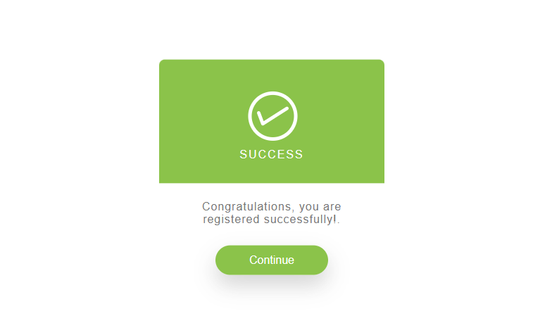

**Database**

<?php

/*

This file contains database configuration assuming you are running mysql using user "root" and password ""

*/

$servername = "localhost";

$username = "root";

$password = "";

$dbname = "sas";

$conn = new mysqli($servername, $username, $password, $dbname);

if ($conn->connect_error) {

    die("Connection failed: " . $conn->connect_error);

}

**Car Book js**

var currentDateTime = new Date();

var year = currentDateTime.getFullYear();

var month = currentDateTime.getMonth() + 1;

var date = currentDateTime.getDate() + 1;

if (date < 10) {

  date = "0" + date;

}

if (month < 10) {

  month = "0" + month;

}

var dateTomorrow = year + "-" + month + "-" + date;

var checkinElem = document.querySelector("#checkin-date");

var checkoutElem = document.querySelector("#checkout-date");

checkinElem.setAttribute("min", dateTomorrow);

checkinElem.onchange = function () {

  checkoutElem.setAttribute("min", this.value);

**Car Book Css**

textarea {

  border-radius: 2px;

  border: 2px solid #777;

  box-sizing: border-box;

  font-size: 1.25em;

  font-family: "Nanum Gothic";

  width: 100%;

  padding: 10px;

}

div.elem-group.inlined input {

  width: 95%;

  display: inline-block;

}

textarea {

  height: 250px;

}

hr {

  border: 1px dotted #ccc;

}

button {

  height: 50px;

  background: orange;

  border: none;

  color: white;

  font-size: 1.25em;

  font-family: "Nanum Gothic";

  border-radius: 4px;

  cursor: pointer;

}

button:hover {

  border: 2px solid black;

}

Welcome

      </div>

    </div>

  </header>

  <nav class="navbar h-nav-resp">

    <ul class="nav-list v-class-resp">

      <li><a href="#Home">Home</a></li>

      <li><a href="#About">About Us</a></li>

      <li><a href="#">Help & Support</a></li>

      <li><a href="#Contact Us">Contact</a></li>

      <li><a href="#">Car Washing</a></li>

    </ul>

    |

    }

    }

    <a href="#" class="user-menu menu-btn flex-align-right">

      <div class="icon-container">

        <img class="user-icon" src="./Images/user.png">

      </div>

      <?php echo "Welcome " . $_SESSION['username'] ?>

      <div class="user-logout" onclick="logout()">

        Logout

      </div>

    </a>

    </div>

    <div class="burger">

      <div class="line"></div>

      <div class="line"></div>

      <div class="line"></div>

    </div>

**Future Scope:**

* In the future scope of our project, we will add chatbot that will interact with users directly. It will also take feedback and will ask questions.
* Since this website is the way that interacts with users, we will develop an app that will be more helpful for users.
* We will add feature of Online payment.
* We will add more cars in our database

**CONCLUSION:**

In comparison to previous experiences, when every activity related to the vehicle rental business was restricted to a physical place alone, the car rental industry has emerged with new delicacies. Even if the physical location has not been completely eliminated, the internet's power has altered the nature of functions and how these tasks are accomplished. Customers may now book vehicles online, rent automobiles online, and have the car delivered to their home if they are a registered member, or they can travel to the office to pick up the car.